e-Learning Available at SSUSA
AHA First Aid/CPR/AED Programs

Survival Systems USA is proud to announce a new way for our clients to receive their American Heart Association First Aid, CPR, AED or HCP certification. In the past, students were required to complete both the academic and practical portions in a classroom setting – requiring a longer “in-house” attendance at a training program. With the improvements in technology, AHA now offers an e-Learning solution that allows students to complete the academic portion of instruction on-line. Once complete, they can print out their certificate and present it at SSUSA for the skills testing.

eLearning courses provide a complete and flexible solution for first time or renewal training for both healthcare providers and lay providers who need to keep their First Aid and/or CPR/AED certification. Students can complete training at their own pace in less time, anywhere with internet capabilities. For students attending other training programs at our facilities, these e-Learning courses are available as an add-on – saving time and money for employers.
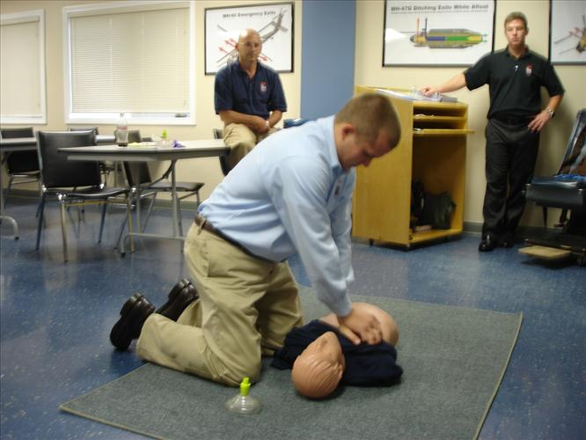
eLearning is a three part process:

*Complete the on-line eLearning course
and print out your completion certificate

* Contact SSUSA to schedule your practice/test session

* Complete your one-on-one practice/test session
with one of our AHA certified instructors. This process takes approximately 30-60 minutes.

If you would like to bring eLearning to your place
of business, contact SSUSA for a group discount.

Students MUST bring a copy on paper of their certification to the practical testing. No exceptions can be made. Students are also allowed one remediation if they do not pass the course on their first attempt. For registration in our e-Learning programs, or to add an e-Learning module to your existing training program, please contact us below:

Survival Systems USA
144 Tower Ave
Groton, CT 06340
860-405-0002
registrar@survivalsystemsinc.com

Options for training include: Online Key Only, Key and Skills Check, and Skills Check Only

