BENEFIT FOR ZAC GORE/FAMILY @ VFW
Featuring the band “Static Cherry”!!!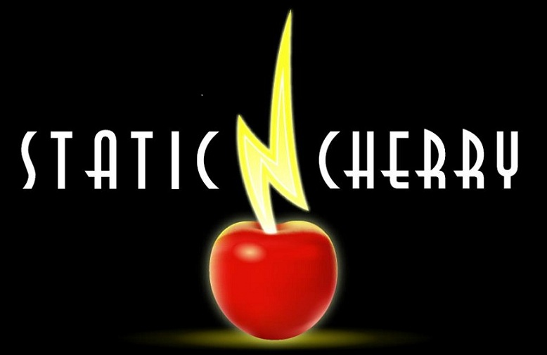
WHEN: JUNE 14, 2013 TIME: 7:00pm – 11:00pm
WHERE: VFW, TAYLOR HILL RD., JEWETT CITY, CT 06351
COST: $15.00/TICKET
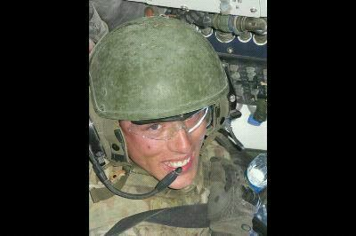
PLEASE HELP SUPPORT ZAC GORE’S PARENTS. ZAC IS A FORMER LISBON RESIDENT WHO WAS SERIOUSLY INJURED WHILE ON ACTIVE DUTY IN AFGHANISTAN IN APRIL 2013. HIS PARENTS HAVE BEEN AT ZAC’S BEDSIDE SINCE HE RETURNED TO THE STATES.
To purchase tickets, buy raffle tickets or make a donation, please contact:
Jodi Potts @ jdjspotts@sbcglobal.net or (860-383-9512)- text or call
Tricia Maynard @ (860-234-0709)- text or call
Michelle Danieluk @ mcdanieluk@gmail.com or (860-748-7639)- text or call
Tickets can also be purchased at the VFW in Jewett City

If you would prefer to make a cash donation, we will forward your donations to Zac’s parents
Please let us know if you would like to donate an item for the raffles ☺
Come out for a night of fun with family & friends…dancing to great music,
50/50 raffle (you don’t have to be present to win), basket raffle, silent
auction, bring your own snacks for your table, all while supporting a local
hero allowing his parents to continue to assist with his recovery.

