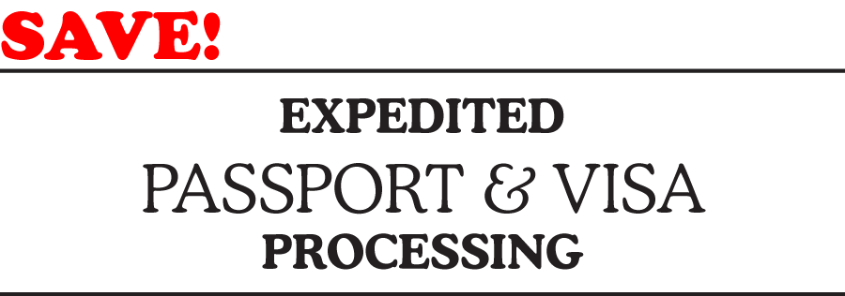


Klingerman Travel has reduced rates for its customers who use CIBT, the largest provider of Passport & Visa services in North America.

Passport & Visa applications and instructions can be obtained online.
Simply go to www.cibt.com and login in the upper right hand corner with account 35064.
Call 800-577-2428 and mention account code 35064 when calling.
CIBT document experts are available –
Monday through Friday
7:30 a.m. – 7:00 p.m. Central Time

