Klingerman Travel, Inc. 860-443-2855 - New London  860-388-1423 - Old Saybrook  http://www.klingermantravel.com | VACATION PACKAGES FROM TRAVEL IMPRESSIONS
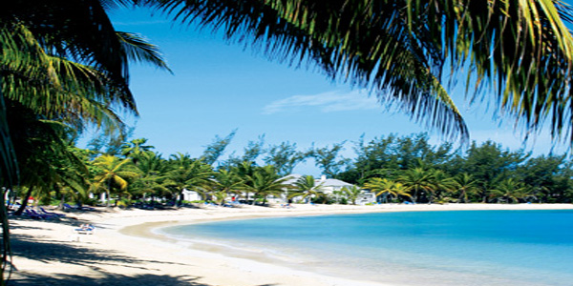


Fall in Love with the Royal St. Kitts Hotel & Casino and receive amazing extras!
More Details
Journey to Jammin' Jamaica. 3 Jammin' nights start at $219
More Details
Book Curacao Now and SAVE!
More Details

