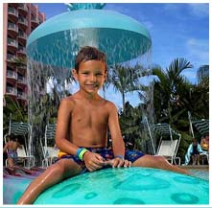  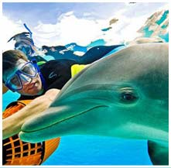  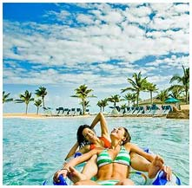 | 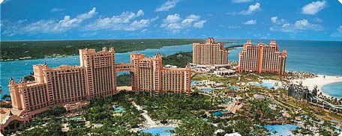  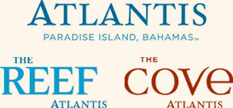
Book a getaway to Atlantis, Paradise Island now and
Kids 11 and under stay
& play FREE!
PLUS
Dining plans are now available from $69 per person, per day
and all dolphin interactions can be booked ahead of time!
Enjoy:
- 141 acres of thrilling waterslides, river rides and pools
- 50,000 marine animals swimming amidst Atlantean ruins
- Swimming with dolphins at the amazing Dolphin Cay†
- The Aura nightclub and the largest casino in the Caribbean
- Endless white sand beaches and more…
Three nights in paradise
start at $485!
Tours operated by Travel Impressions. Rate is land only, per person, based on double occupancy in lowest available room category, and includes roundtrip hotel transfers, 3-night hotel accommodations, hotel tax and service charges. Super SunBreak promotional rate requires a 2-night minimum stay and is valid for bookings made by 8/31/09 for travel now through 12/16/09.†Dolphin interactions at Dolphin Cay are available at an additional fee starting at $120 and can be pre-booked. Blackout, weekend, holiday peak season surcharges apply. Rate and promotion are accurate at time of publication and are subject to changes, exceptions, cancellation charges and restrictions. All advertised savings are reflected in price. Rates subject to change based on currency fluctuations. Not responsible for errors or omissions in the publication of this ad. Additional higher priced packages available.

