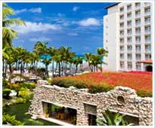  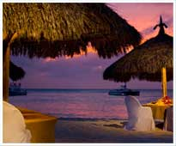  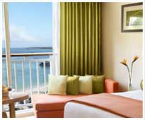
  THREE FOR FREE at
  The Hyatt Regency Aruba
  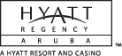 | Guests will receive:  - Every 5th night free  - Full breakfast for two daily  - Guaranteed one-category  room upgrade*
  Experience the all-new Hyatt Regency Aruba Resort & Casino, where luxurious pampering and exquisite touches enhance every moment of your visit. Breathe in fresh tropical breezes bringing the captivating scents of this island retreat into each corner of this impeccably renewed Aruba hotel and resort. Delight in the beauty of the new design, from intimate gathering spaces to elegantly modern guestrooms. Select this luxury hotel in Aruba, and transform your island escape from expected to distinctly remarkable.
  5 nights start at $995
Tours operated by Travel Impressions. Three for Free promotional rate is valid for bookings made by 12/19/09 and for travel from 6/26/09 - 12/22/09. Rate is land only, per person, based on double occupancy in lowest available room category, and includes roundtrip airport/hotel transfers, 5 night hotel accommodations and hotel tax. 5th night free offer is consecutive. 5 night minimum stay applies to the Three for Free promotion. *Guaranteed one- category room upgrade applies to certain room categories only. Blackout, weekend, holiday peak season surcharges apply. Rate and promotion are accurate at time of publication and are subject to changes, exceptions, cancellation charges and restrictions. All advertised savings are reflected in price. Rate is subject to change based on currency fluctuations. Not responsible for errors or omissions in the publication of this ad. Additional higher priced packages available. Valid for new bookings only.

