NEW GROUND LLC HOME EARNS NATIONAL GREEN BUILDING CERTIFICATION
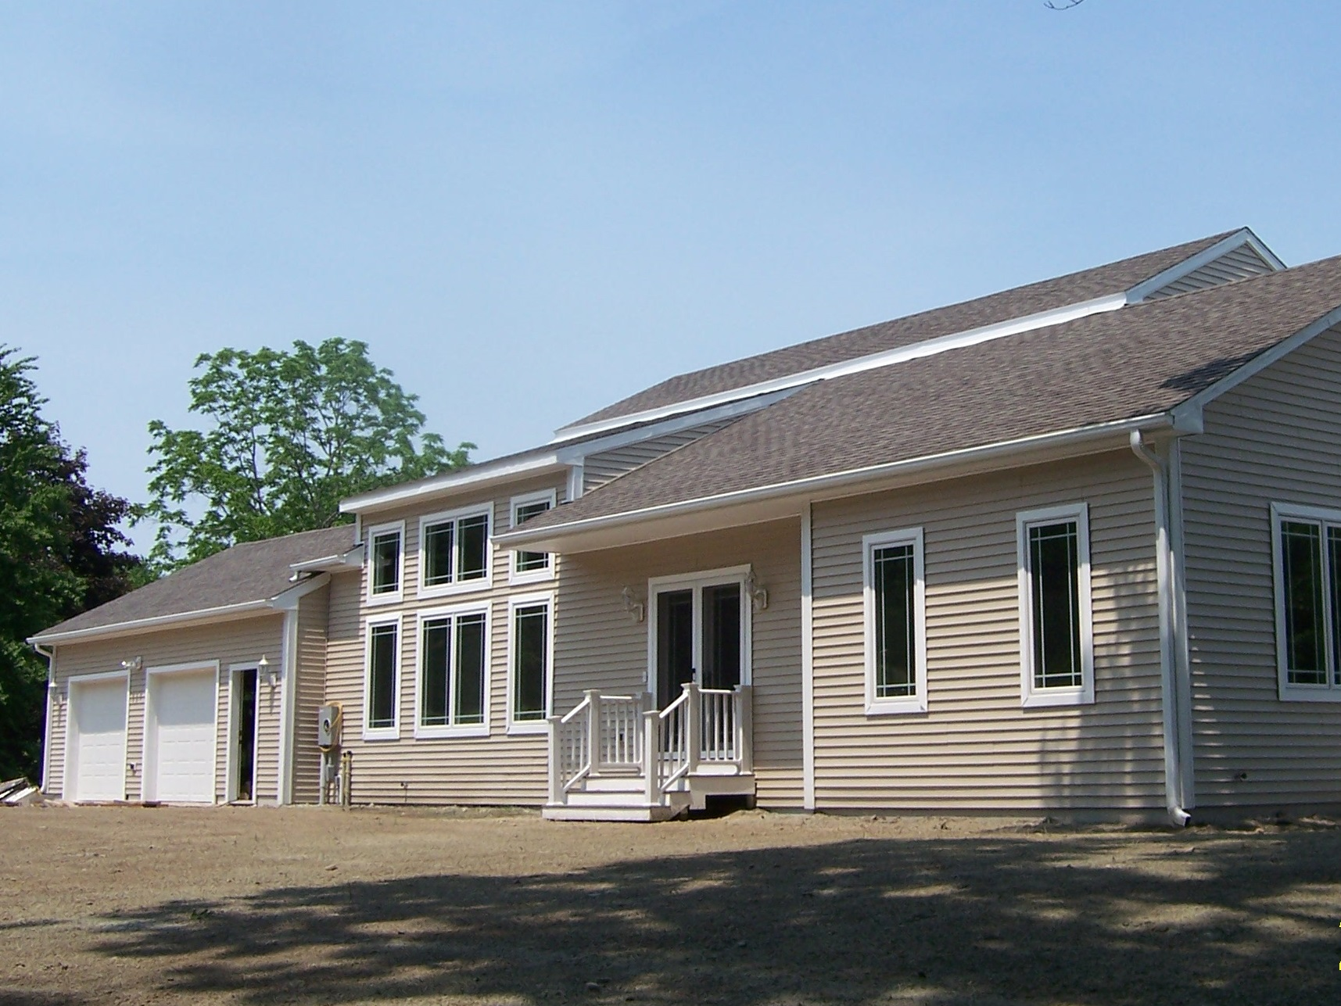
The Builders Association of Eastern Connecticut (BAEC) is pleased to announce that a new home designed and built by BAEC member Jason Nowosad of New Ground LLC has received Gold level National Green Building Certification from the National Association of Home Builders (NAHB) Research Center. This custom home was completed in July 2010 and is one of only a few homes in the state to achieve the designation. The gold level indicates that the home’s HERS score is 44, meaning it is 56% more efficient than a standard home.

“Jason is one of only a dozen builders in eastern Connecticut who has earned the Certified Green Professional credential from the National Association of Home Builders,” notes Renee Main, Executive Officer of the BAEC. The designation recognizes builders, remodelers and other industry professionals who incorporate green building principles into homes— without driving up the cost of construction. Class work leading to the designation provides a solid background in green building methods “The home certification process is costly and extremely time consuming. To go that extra mile to certify his homes as well shows Jason is very serious about his craft.”

“Builders who have their homes Green Certified through the NAHB Research Center’s National Green Building Certification Program are not just saying they build green homes,” said Michael Luzier, NAHB Research Center president. “They’re proving it! The Research Center requires third-party verification of every green point claimed by a builder, so seeing our Green Certified certification mark on a home ensures the homebuyer that the builder’s green claims are true.”

Jason started his company New Ground LLC in 2004 and has been building green homes ever since. “All of our homes have been green, but we’ve never sought the certification from NAHB before” says Nowosad, “We were really pleased to achieve the gold level on our application for certification. Residential energy use accounts for 33% of total energy use in Connecticut according to the Department of Energy. I hope to help reduce that number by building greener homes that use less energy at every phase from the construction process through the years of operating the building, which should last a very long time.” To learn more about Jason’s homes go to http://www.newgroundconstruction.com/ .
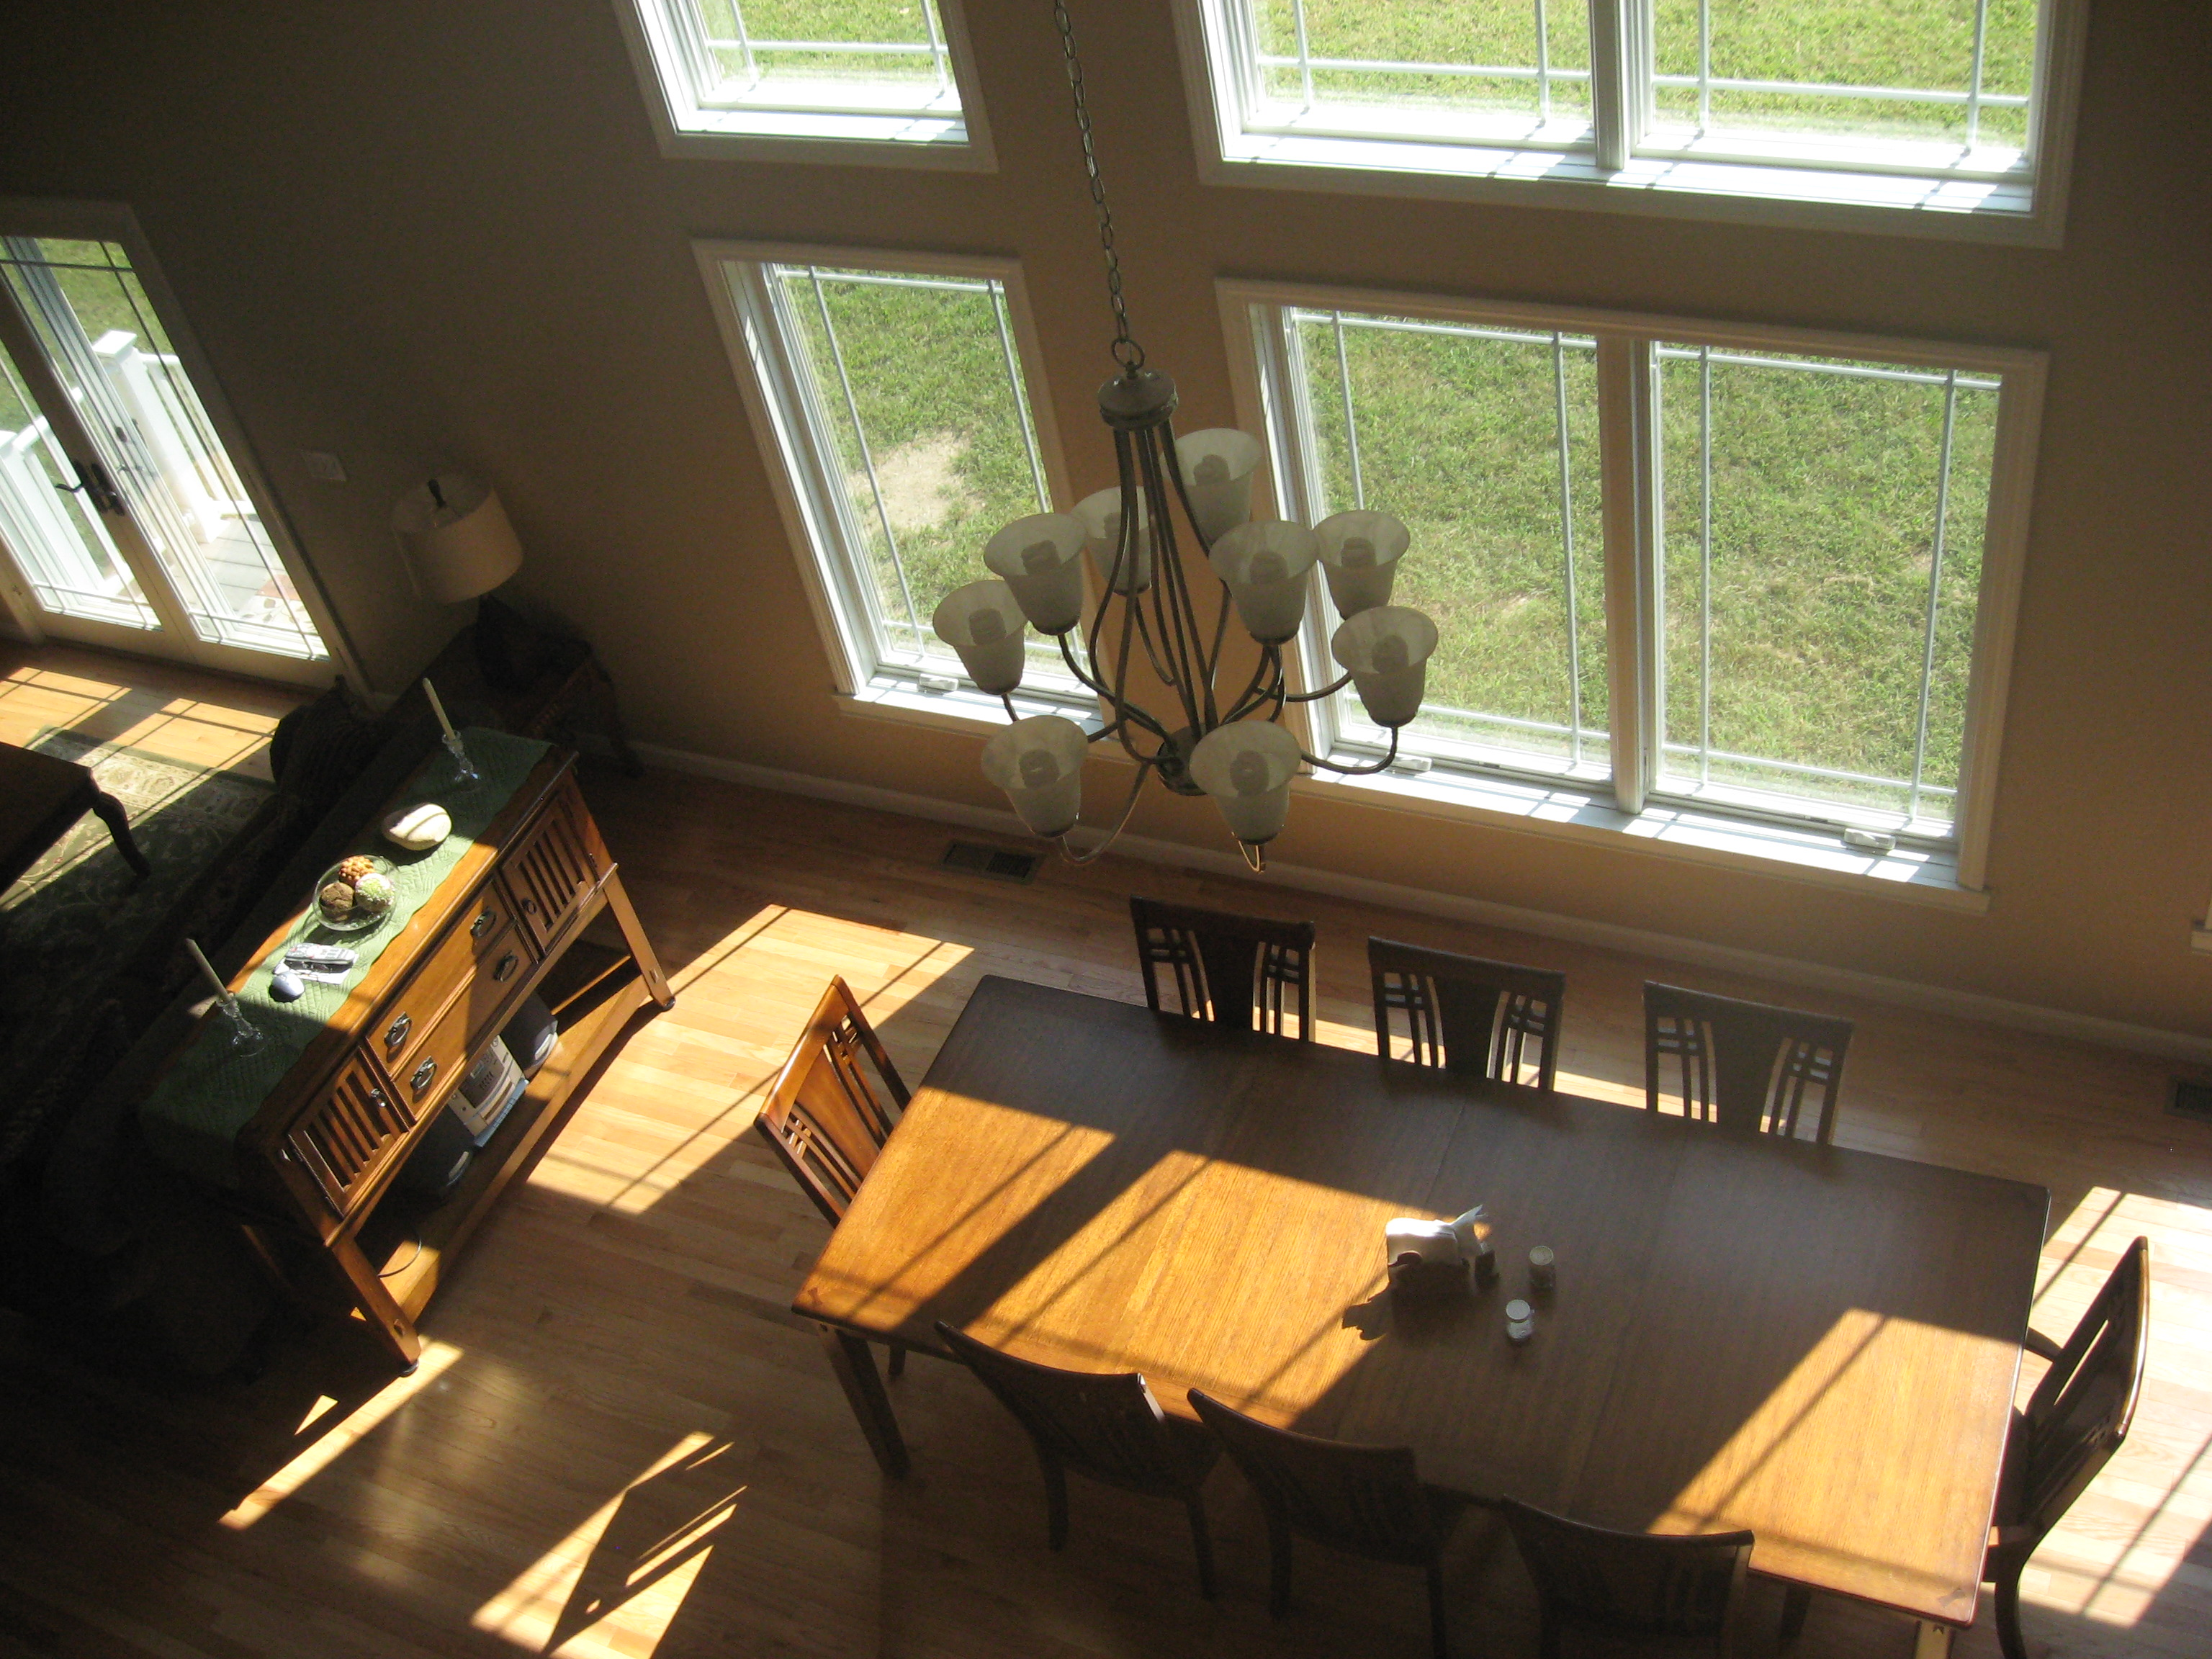
The 2,600 square foot home was designed with resource efficiency in mind using dimensions that reduce the need for cutting standard size construction materials and simply making the most of space and materials. The home in North Stonington, like all of New Ground LLC’s homes, is built on a foundation of insulated concrete forms. The forms snap together much like legos® and the concrete is poured in the middle. Insulating the basement helps the home retain energy. Once the foundation is poured, the home was then framed using advanced framing techniques to minimize construction waste and also build a structure that is both strong and free of gaps where air can escape.

The home is insulated with non-toxic high efficiency spray foam and gets its heat, hot water, and cool air from an onsite horizontal loop ground source heat pump. Energy star approved windows and appliances, CFL lighting and solar tempering further increase the home’s energy efficiency. The home owner, Robert Demara says, "I would not understand, with all the incentives in place currently, both local and federal, why someone would choose anything other than green building."
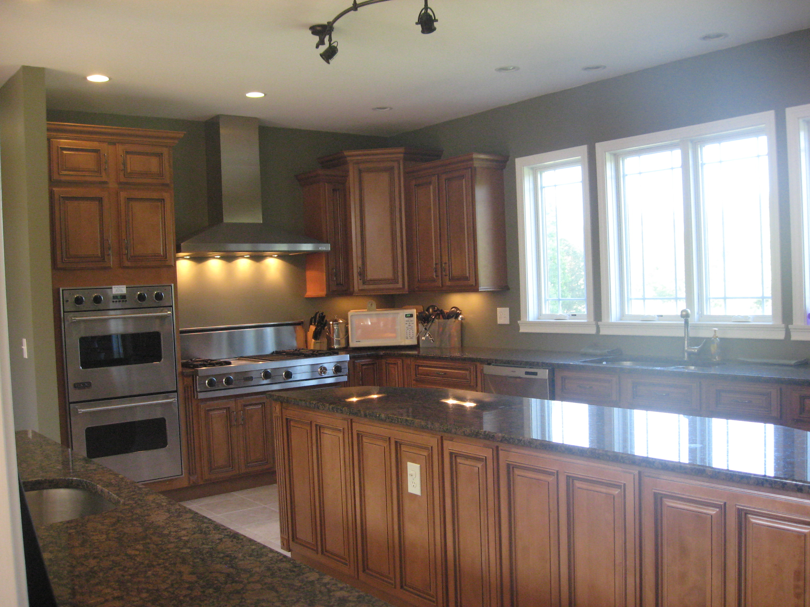
The custom home was also designed with the desires of the client in mind and Jason worked closely with the customer to create a home that is not only green but also very comfortable. The cape style home features an open floor plan with a beautiful spacious kitchen, a living room with cathedral ceiling, and master bathroom with a Jacuzzi tub. There are also two other bedrooms, each with a private bath.

Additional information on the NAHB Research Center’s National Green Building Certification Program is available at www.nahbgreen.org/certification.

