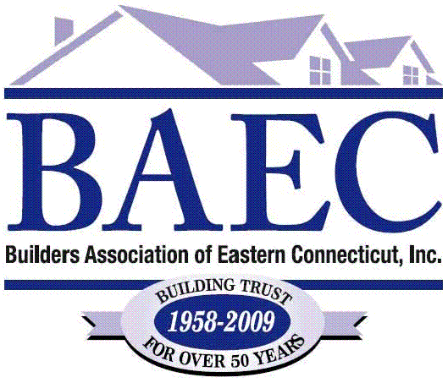
Certified Green Professionals (CGP)

Ellery Kington Coastal Home Inspection 860-572-0022

Richard Wildermuth Connecticut Valley Homes 860-739-6913

Dave Copeland D. H. Copeland Builders Inc. 860-928-2400

Darren Drobiak Erik’s Design Build 860-376-5289

Hope Sheldon General Woodcraft 860-444-9663

John George John C. George Co., Inc. 860-886-7334

Norton Wheeler III Mystic River Building Co. 860-536-0102

Jason Nowosad New Ground LLC 860-428-2954

Denise Nott Nutmeg Bldg & Remodeling 860-572-9606

Terence Beaty Prudential CT Realty 203-913-3535

David Aiken Senkow Builders LLC 860-442-0800

Thomas Buxton T.F. Buxton 860-599-8660

James Williams T.F. Buxton 860-599-8660

John MacPherson The Kitchen Guy 860-367-0209

