Remodeling Tips - Building Green with Rainscreen Wood Siding
One of the remodeling projects with the largest impacts to a home’s value and salability is to improve its ‘curb appeal’. A beautiful and natural way to improve the curb appeal of your home is to replace outdated, worn out or ugly siding with a brand new face for your home. Rainscreen siding is a beautiful, healthy and long lasting sustainable design practice that is rapidly gaining momentum and popularity throughout the US and beyond.
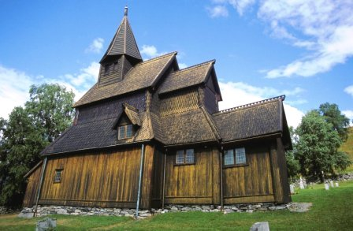
What is a rain screen system and why should I use it? Rainscreen systems have been around since the Vikings used them on stave churches late 12th century and several examples from this are still standing in Norway today. Stated simply, a rainscreen provides an exterior siding material to protect and keep the elements away from the inside of your home. An air space is left behind the rainscreen siding to allow moisture from within the home to escape. The elimination of moisture minimizes rot and decay and can extend the life of your home significantly.
Rain Screen Wood Siding Benefits:
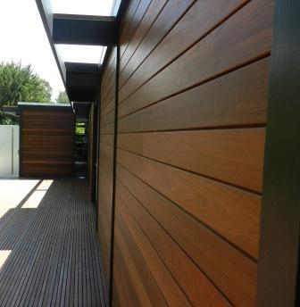
- A rainscreen wood siding system creates a beautiful face for the exterior of your home, adding value and beauty to your home or outbuilding.
- Wood rainscreen siding is an all natural, renewable resource.
- Rainscreen systems protect the outside of your home
- Rainscreen siding systems minimize moisture inside the home, reducing the ability for mold and mildew to create rot and decay
- Rainscreen systems can extend the life of a building or structure significantly
- Well designed rainscreen siding installations can dramatically reduce maintenance costs for your home.
To learn more about rainscreen wood siding systems, please visit our member’s website: www.mataverdedecking.com/rain-screen-products/

