Add a New Deck or Spruce Up an Existing Deck!
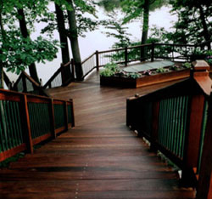
Very few projects add to the value of your home more than a new kitchen or a new deck. A deck adds more usable living space to your home by extending your home outdoors. Let’s face it, other than your kitchen, is there any other room in your house that provides as much relaxation, enjoyment, entertainment or fun with family and friends than a deck? If you are considering a new deck or replacing decking boards on an existing deck, the BAEC has many qualified contractors who can help you build the deck of your dreams.
If you are planning to build a new deck, have a qualified licensed contractor help you with your design, permitting and construction of your deck project. A well designed and constructed deck will add immeasurably to your home’s value and your personal enjoyment. You’re on your way to a new deck…go ahead…live a little!
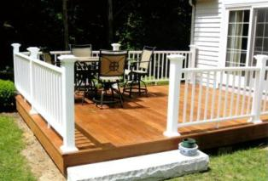
If you already have a deck but plan to replace old or outdated decking boards on an existing deck, have a qualified construction professional check out your deck’s framing structure, fastening and code compliance. Once they are satisfied with the strength and structure of your deck, replacing the deck boards is not only safer but can add beauty and enjoyment to your life. There are many decking materials to choose from including plastic and composite decking, softwoods and the increasingly popular high density hardwood decking species like Ipe, Cumaru and Garapa.
For a comprehensive guidebook that offers you a clear comparison of all the decking material options available you, please feel free to download, “The Ultimate Guide to Selecting the Right Decking Material”. This fact-filled FREE Decking Guide is packed with useful knowledge that will help you make an informed decision about choosing the decking that will work best for you.


