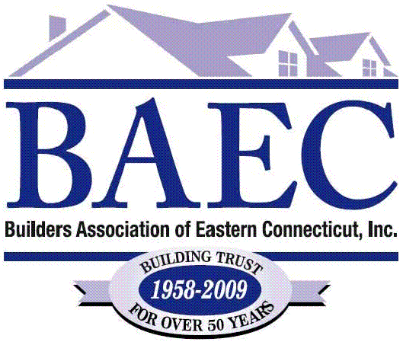
Certified Green
Professionals (CGP)

Ark Contractors 203-779-9066
Coastal Home Inspection 860-572-0022

Connecticut Valley Homes 860-739-6913

Creative Enclosures 860-886-7631

D. H. Copeland Builders Inc. 860-928-2400

Erik’s Design Build 860-376-5289

John C. George Co., Inc. 860-886-7334

Mystic River Building Co. 860-536-0102

Nutmeg Bldg & Remodeling 860-572-9606

The Greensulators 860-376-5151

The Kitchen Guy 860-367-0209

